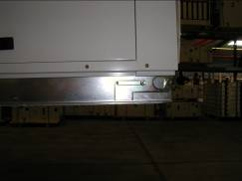
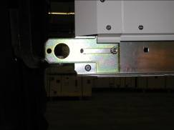

Vis A

Lifting lugs
After unfixing the screw ref A, move the 4 lifting lugs out of the frame then fix it again
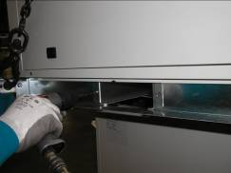
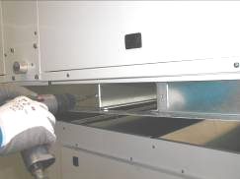

Remove the 2 screws for each forklift protection
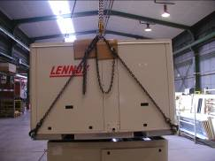
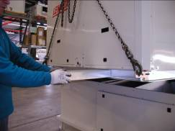

Remove the forklift protection before putting the machine on the roofcurb
Use protection between the machine and the lifting rings

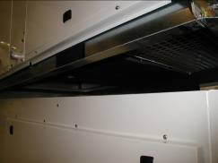
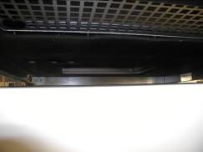

The baltic is moving down to the curb, the forklift protection are removed Underneath view

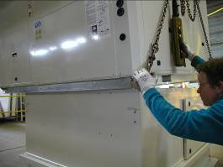
Put smoothly the heaviest side and then adjust
(Compressor side).

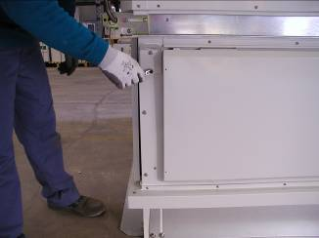
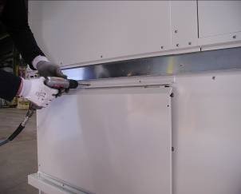

Curb
Lifting lugs

B

Take off the Roofcurb lifting lug screws. Take off the top angle from the exhaust hood
Aswell as the screws rep B that will be used to fix the heat recovery module

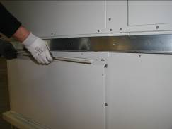
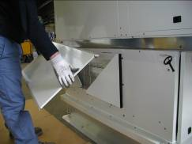

Cut the hood top angle sealant and take off the angle. Take off the hood top sheetmetal.
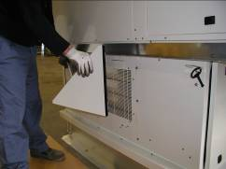
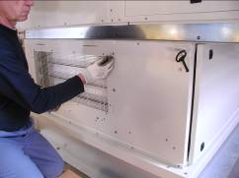

Take off the 2 hood triangle sides and the 3 last screws that will be used to fix the heat recovery support
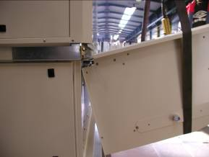
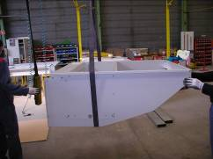

Bring the support (by crane or by hand) close to the Rooftop.
The top bend must fit into the frame rectangle slots

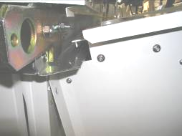
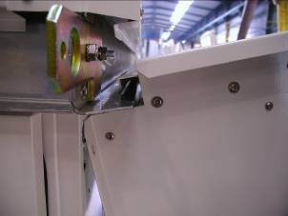

The sheetmetal return must inside the frame slot.
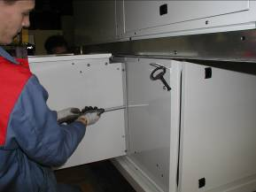
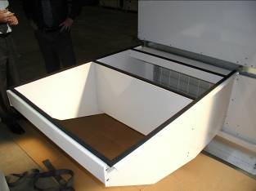

Joint noir 20 x 10

Assembly the module support on the roofcurb side:
3 screws 6 x 20 inox on both sides
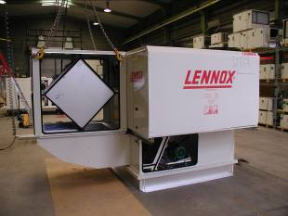
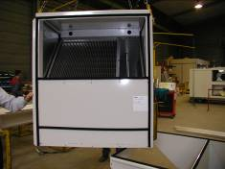

Bring the module on the support. Check the good shape of the 20 x 10 black gaskets.

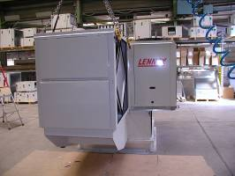
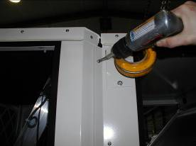

End view
Use the self drilling screw 5 x 16 to assembly the module flanges directly in the Rooftop Corners

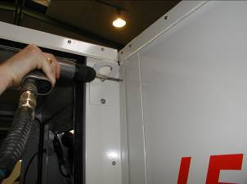
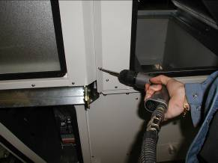

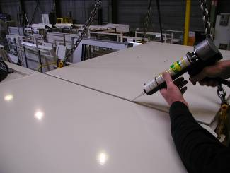
Idem on the right side
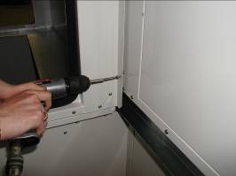

Putty the polyurethane sealant inside the jonction between rooftop and heatrecovery module.

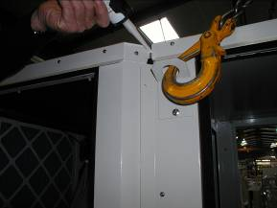
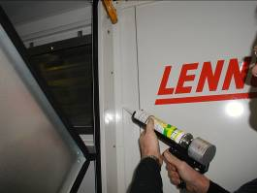

Putty very carefully on the roof side and then and flanges sides
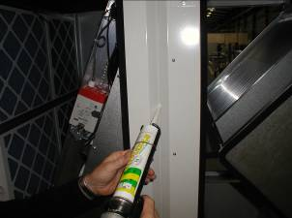
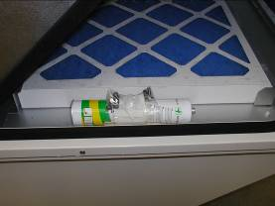

The following components should be delivered inside the module.
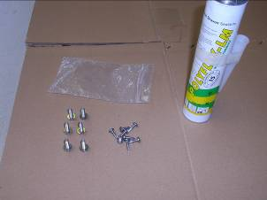
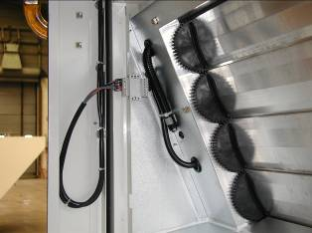

Connect the 7 points plug from the module to the female awaiting in the rooftop (Actuator + Air pressure switch)

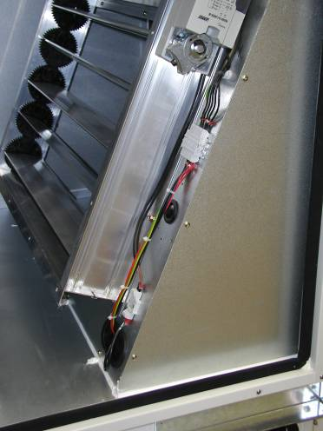

Do the electric connection :
Roofcurb/ Rooftop

Curb extraction fan power
7 points plug

Roofcurb actuator
3 points plug

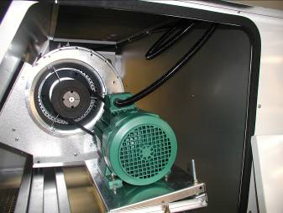

Important:
Check that the extraction fan wire is not in contact with the fan wheel. The fan support is removable and the wire is long enough to put the fan out the roofcurb.

