Alarmcontact Climatic 60

J14; C3 NC7/NO7

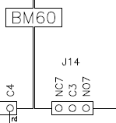

Vrijgave; DI7/DIC1

